**Introduction**

The training is designed with 3 virtual machines with various web application(s):

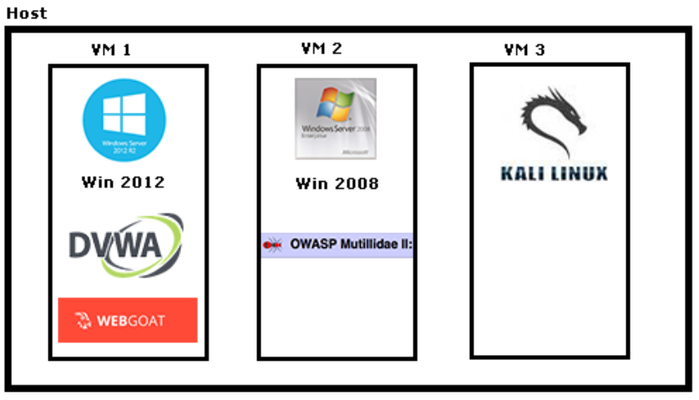

1. VM login:
   1. Kali Linux:
      1. Username: root
      2. Password: toor
   2. Win 2012 & 2008: no login required
2. Lab environment is set as DHCP (obtain IP address automatically). Record IP address of every PC.
   1. Kali Linux (IP): ________________
   2. Windows Server 2012 (IP): ________________
   3. Windows Server 2008 (IP): ________________

This training will cover only *DVWA. OWASP Webgoat* and *OWASP Mutillidae* are having the same architecture and testing flow. They are designed for participants to use as extra exercises.